One Bridge  a concept in progress |  | 

Contents
Our Why  With any problem we tackle, there should be a good reason behind why we are doing so.  The Big Idea  We have many grand ideas as to how to make this come to life, and those may morph as we go.  - Scale, Contact, & Collaboration  What’s Next  We have big plans, so here is where you will see the status of those. |  |  |  | What is One Bridge?  The one place for turning ideas or problems into future possibilities.  This concept is an idea to solve a pervasive problem across the business and that is – Where does a person in the business go when they have a problem or an improvement idea? Either there are many places one could go, or the place is unknown. If the distance to travel from problem to solution is too difficult, then one might just deal with the problem or snuff out the idea. This is not what we want to encourage.  Instead we want to offer ONE venue that anyone could come to with a problem or an idea, whereby we can help that problem get tackled or that idea come to fruition. Simply put, we want to help you help yourself or your team.  ~ Awais & Stacie

 |  |  | Our why  why do we want to build one bridge?  During the spring cohort of 2018 facilitated by the Innovation team, a few team members conducted a survey across many various business areas that we knew including but not limited to: Global Corporate Trust Services, USBI, Securities Processing & Vault Services, and TOS. The survey was simple. We asked these business line resources if they had a problem or an idea to improve something, like a future project, did they know how to submit that idea or who to talk to about it. The survey not only confirmed our hunch about the problem, but provided us some insightful statistics on the problem at hand.  - We polled participants on if they knew where to go with an issue or solution idea:​  - 64% did not know where to go (9)​  - 36% did know where to go (5)​  - We polled participants where they went if they knew where to go:​  - All 5 participants had a DIFFERENT answer
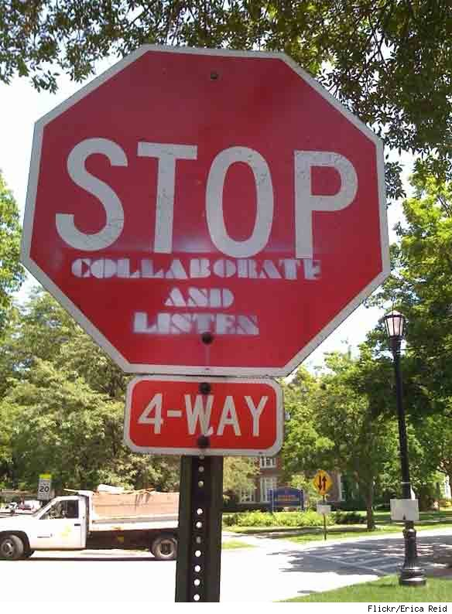[

The big idea

and so the birth of one bridge began
We thought it best to offer a kind of one stop shop whereby anyone could post a problem or throw out a solution idea that they have. Once the problem or idea was floated out there, the team behind One Bridge would review it, ask qualifying questions as needed, and then call up any other contacts for consultation purposes. Once we have had enough time to thoroughly review the problem or issue, our goal was to find out the best possible approach for resolving that problem or implementing that idea. After we had accomplished our goal, we would post a resolution to the problem or idea with the ideal approach and follow that up with a meeting with the resource(s) who would be able to take it to the next step. This meeting is crucial, because we wanted to ensure that all the knowledge we obtained was properly passed onto the resource(s) who needed it, but also that we had passed our business line requestor onto capable hands where expectations were understood.
SCALE DoesN’t matter  a Problem, idea, or question - all are welcome  If you have a question, then we can get an answer for you. You may be looking for a contact for your issue, then we can find one for you. You have an idea we can help you bring that to light.  It does not matter that what are you trying to solve, we can be engaged so that things can progress for you. | 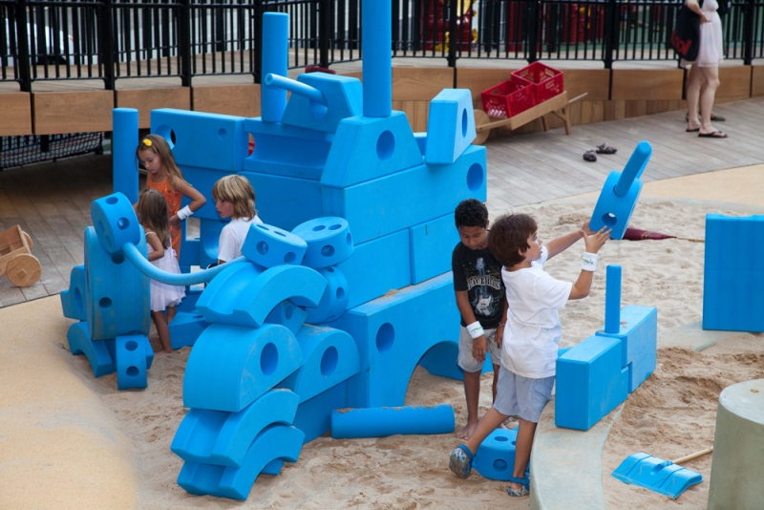
 |  |  | contacting us  if You NEED us then INVOKE us  If you want to connect with us because you have problems to solve or a brilliant idea to improve the way you do things, then we will find the right people for you. We are also willing to move on with you through stages as needed. However, when you are making strides forward with the right people then you don’t have to keep us involved.  We may get updates from you on and off to keep things up to date at our end as much as we can, so that in case if you ever need us again we are there to help. However, we will always want to hear of a successful conclusion to the original problem or idea.
CollaboratE  better with tools like yammer  Forming, Storming, Norming, Performing. Collaboration is the key. We will have tools like Yammer to enhance collaboration as well as others on the Office 365 platform we may leverage.  Also, if you are in the TOS organization you know about TOS2020. Therefore, if you have an idea that aligns well with the vision of TOS2020 and you want to validate your thoughts, you can come to One Bridge. You can take your idea to the appropriate work stream, but if you want to just discuss it before doing so, we are willing to listen and help if we can. | 
 |  | what’s next  Put a new idea through one bridge  The only way to know if something will work is to give it a try, and so that is what we are planning to do. We need an idea to put through the paces and give One Bridge a try. We know there will be changes to make along the way, but are expecting that with every idea we put through One Bridge, the better it will get.  Our plan is to get One Bridge setup on Idea Place, so that we can establish this as a platform and start working on the idea as we expect to. Currently, we are waiting on the Innovation team to get One Bridge setup, so that we can continue with this exercise.  Once we have One Bridge setup, we will take an idea through the process. Our first idea is from GFS, so please reach out if you are interested in keeping abreast of our journey with One Bridge.

what’s Different

One bridge unique values: All five fingures are not the same
OneBridge is different from IdeaPlace, since IdeaPlace is more of a platform to host applications. OneBridge has more similarities with Bright Ideas. However, from our experience, Bright Ideas lack the agility, thing really don’t seem to move forward once they are in Bright Ideas. We did submit an idea in Bright Ideas as POC, and things remain static with that Idea till today. Possibly Bright Ideas has some unresolved questions and struggling to tackle those. OneBridge is focusing on those bottleneck areas to bring agility to Innovation, to actually make things happen. These are highlighted below through the values OneBridge is bringing forth:

Allan

- OneBridge value additions:
  - Setting up a path for idea to fruition.
  - One Nod
    - With OneBridge all you need to confirm is that BL needs it.
    - No need for CAPEX committee approval. \
    - No need to prove your point to the whole enterprise.
    - No need to get votes from people who are outside your business domain (Business Line)
    - No need to build Canvases, pitches to prove yourself to innovation groups to get funded by them.
    - This works well for ideas, solving problems which can’t become projects due to long project queues.
    - The question we are answering her is that if BL can’t fund an idea into a project then will BL employees keep doing things manually and keep creating for example large spread sheets laboriously getting data from one system to another. Then how about validating data, how about manual QC (Quality Control).
  - Powerful combo: business experts and technology experts.
  - TOS/BL Doers Village
    - TOS teams
      - TOS organization
      - TOS teams/groups offerings & tools
      - Frameworks/Reusable apps to build things with minimal to no code
      - Integration points.
      - Engagement Models.
      - Business as usual models
      - Some roles are meant to add capabilities/features/more users within their technology/system and looking forward to such chances.
      - Positive impacts on performance Reviews.
      - There is a longing to learn new technology
      - Enablement Models. Different TOS groups can use each other’s technology.
    - BL partners.
      - BL organization
      - Data owners
      - Process owners
      - Knowledge of software systems being used by BL
      - Who can prioritize the need?
      - Funding calls.
      - Some BLs have technical teams. Some BL people can code too.
      - Positive impacts on performance Reviews
      - TOS can teach BL some tricks.
      - BL enablement.
    - Strategy teams.
      - Overall Enterprise strategy. TOS2020
      - How TOS priorities are being realigned.
      - How TOS groups will be realigned
      - How TOS teams’ offerings will be realigned
      - Positive impacts on performance Reviews.
  - OneBridge COE
    - COE constructs the village while handling more ideas and learning along the way.
    - TOS/BL Village will be digitized, and connections will be automated. However, COE team will still be required to respond to Idea submitter in an agile manner and efficiently traverse through TOS/BL village.
    - Constructing village, then digitizing it and bringing automation to this is a very long process or never-ending continuous improvement process.
    - COE can help evolve/enhance TOS teams engagement models.
    - COE can create a model/plan to help managers defragment work hours to build ideas. Create resources pool where TOS members can use each other’s technology.
    - COE can work on funding model.
  - No Fund, no problem!!! (At least hope so)
    - There can be minimal coding or build with no code possibility, if right TOS groups are found.
    - Best gain is through TOS groups who have automated their offerings.
    - Some may love to spend extra hours for an idea they like.
    - If performance is accounted for this kind of additional work, then that can generate the willpower.
  - Defragmenting work hours and consuming them to build ideas.
    - TOS/BL people may have few hours free from here and there. We can see how COE can help here.
    - TOS groups are looking to add on capabilities (already have existing licenses) and have the capacity to serve more. And they want to serve more.
    - Some TOS team roles are designated to enhance technology usability. They can work under business as usual model.
- OneBridge sequence:
  - Idea Submitter -> OneBridge COE -> TOS/BL Village.
  - Collaboration - Between above three actors
  - Handing Over - Building the team that includes idea submitter and TOS/BL Village people to take through the idea. COE will be involved in status calls.
- Funding
  - Intuitive funding model that can be enriched with knowledge gained and digitizing/automating that knowledge.
    - Minimal Optimized Funding
    - Third level of funding outside CAPEX and innovation group funding.
    - BL or bank may have some funding available for the team established to build an idea, if really needed.
    - Leveraging point 1(f) and 1(g).

Entrata Story by Stacie:

I don't have any hard and fast data points right now, but just wanted to illustrate my points through a story where I have some dates to lean upon.
Entrata is a new BPM application that was released into production earlier this year. Here is the journey that it took to get to this release:
- Sept 2012 my team started analyzing the Setup Fee Billing & Payment process
- The analysis from Sept was presented for CapEx and determined a project could not be funded at that time
- Pretty much every Fall thereafter, my team dusted off the analysis from Sept 2012 and resubmitted for CapEx
- In 2017 the BL partnered with CIE and my team to perform deep analysis on the current fees process
- Oct 2017 my team, CIE and BL presented to Dale Smith and others a solution to present for CapEx
- US Bank determine to retire Lotus Notes (Fees process leveraged a Lotus Notes database)
- Automating the Fees process was submitted as a CapEx and funded under the WM&SS Notes Workflow Applications to BPM project
- The Notes ... to BPM project kicked off in the beginning of 2018
- Entrata (the BPM solution for the Fees process) released to production in Feb 2019
Take away - it took us 7 YEARS from concept to production! 😮
Awais and I plan to solicit some folks for some data to pass back to you based upon the pain points that I had illustrated on our call, which was primarily around the following "TOS is often looked upon as an impediment to business improvements involving technology.", because:
- BL is often told they cannot have improvement x, because there is no project funded to deliver x.
- BL often goes outside of TOS for solutions and/or consultancy, because TOS takes too long to respond or gives a response like #2 above.
- BL often waits years for an improvement, because it takes that long to attain steering committee approval for a funded project.
Sorry it took me so long to draft up my story for Entrata, which by the way is some kind of Latin term for fees or money, but here it is. We'll come back around on the results we get from our solicitation.
Email to inquire BL (Primary Research):
Good afternoon.
I'm doing a little research with the Innovation team on a concept to explore based upon the following hypothesis -
"TOS is often looked upon as an impediment to business improvements involving technology."
First off, let me know if you agree or disagree with this, and secondly, please expand upon your experience to date that might prove your stance.
For example -
- If you submitted an idea for project consideration, how long did it take to fund that project?
  - If it was funded, then how long did it take to start the project?
  - If it wasn't funded, what did you do?
- Did you leverage resources outside of TOS for solutions and/or consultancy?
  - If so, what did you use them for and why did you go outside?
  - If not, did you consider doing so?
PS - I think TOS does a lot of great work, but I also think we can do better. It is in that spirit of improvement that I seek this feedback.
Thanks,
Feedback from BL

Resp # 1
Hi Stacie,
I do agree with this statement and I have a CTAO example below.
TOS doesn’t seem to be able to fund the necessary resources to support the CTAO system, which has expanded greatly since inception. I am actually in the process right now of gathering time estimates to submit a proposal for our CME business to fund specific resources for CME BAU development. There are over 500 user stories in the backlog. The time to the end of the year is dedicated to defect clean up, indicating a problem in testing or user story capture. Progress is so slow! CapEx funded projects seem to infringe on general BAU development when those should be separately funded resources. I’m also confused about the roles - what does the TOS BA do versus the TTSS BA.
Thanks for asking 😊 Dyan
Dyan M Huhta
Senior Vice President | Trust Review National Manager
Global Corporate Trust
p. 206.344.4616 | a. 425.442.9842 | dyan.huhta@usbank.com
U.S. Bank
Seattle Tower
1420 Fifth Ave, Seattle, WA 98101 | PD-WA-T7CT | usbank.com

Knowledge Base Needed but may be not if we focus under Masood - Coverage will be more.
Redo Survey.

Product Manager
Something Like idea place where business lines (Product Owners most commonly Balagesubramanian->Tobit,Allen) submit ideas and technology teams (under Masood) pick them up, expand the idea, high level design, ask questions to satisfy requirements, if it looks good to investment committee, it becomes Capex (turned over to implementation), otherwise it gets dropped.

